[2023 테마형(어학연수과정) 한국유학박람회 개최 안내]

교육부 국립국제교육원에서는 『2023 테마형(어학연수과정) 한국유학박람회』를 아래와 같이 개최합니다.
1. 행사명: 2023 테마형(어학연수과정) 한국유학박람회
2. 기 간: 2023. 4. 4.(화) ~ 4. 10.(월) <1주간>
3. 주요 콘텐츠
o 한국어 어학연수 유학 안내, 장학금, 대학정보, 온라인 입학신청, 온라인 상담, 채팅상담 등
4. 참가대학: 54개교
5. 접속 및 참가방법
O 한국유학종합시스템 웹사이트(www.studyinkorea.go.kr)에 접속하여 박람회 링크 선택
O 등록(Registration) 후 박람회 기간 중 사이트 방문

[Study in Korea Education Fair by theme(Korean Language Programs) 2023]
It is our pleasure to announce that NIIED will hold “Study in Korea Education Fair by theme(Korean Language Programs) 2023” for international students.
- Name of the event: Study in Korea Education Fair by theme(Korean Language Programs) 2023
- Date: Apr 4th (Tue) ~ Apr 10th (Mon)
3. Introduction of main contents
- Studying in Korea(Korean Language Programs), scholarship programs, information about Korean Universities, online application, online consultation, Live Chat
4. Participating universities: 54 universities
5. How to access and join the online education fair (Please see the attachment.)
- Visit the Study in Korea website (www.studyinkorea.go.kr) to select the education fair link.
- Complete the registration and visit the website during the online education fair.

<Attachment>
How to register“Study in Korea Education Fair by theme(Korean Language Programs) 2023”
- Visit the Study in Korea website“www.studyinkorea.go.kr”
- Click“Study in Korea Education Fair by theme(Korean Language Programs) 2023”
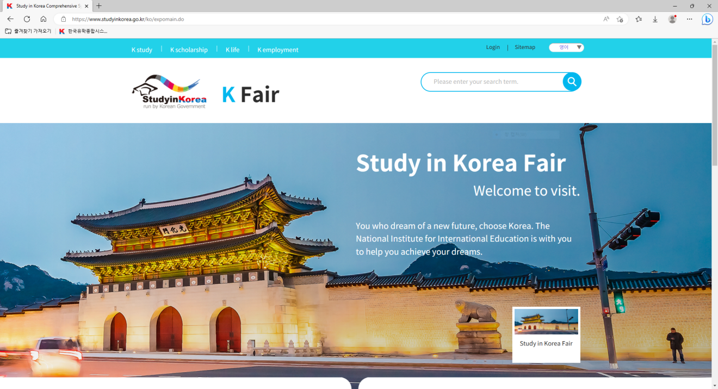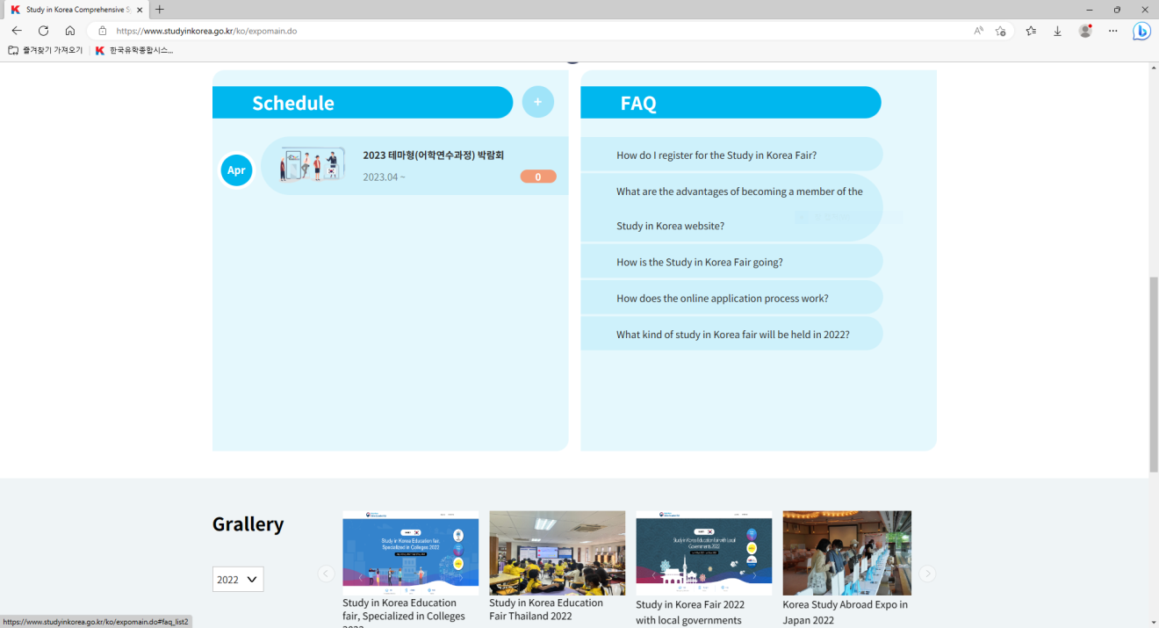

- Click “Registration” to join the Fair.
- Please visit the education fair page during Mar 24th (Fri) ~ Apr 10th (Mon).

