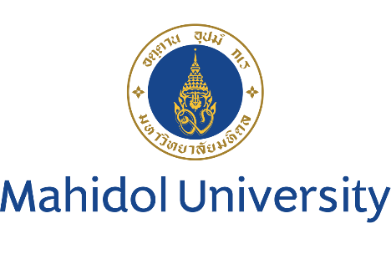

Proposal for
DCU Global Youth Camp: Youth Voices in Digital Era
7-12 January 2024

1. Introduction
The "Youth Voices in a Digital Era" Global Youth Camp seeks to harness the potential of global collaboration and innovative thinking by bringing together 100+ students from around the world. This initiative is designed to empower participants to become agents of positive change by addressing pressing global issues through the lens of the Sustainable Development Goals (SDGs) while fostering international camaraderie. In addition to raising awareness of the SDGs, DCU Global Youth Camp offers participants plenty of opportunities for self-development such as broadening their outlook and developing greater intercultural skills through interaction with people from different backgrounds and cultures. Additionally, they will develop teamwork and interpersonal skills by cooperating to tackle global challenges in a new environment different from home.

Participants will be given the choice to engage with one of four distinct and essential modules: Biology and Environment, Cyber-security and AI, Financial Literacy and Economic Growth and Diversity and Inclusiveness

A unique aspect of this program is the opportunity it provides for students to engage with not only their peers from around the world but also accomplished instructors from prestigious institutions such as the National University of Singapore and the University of Southern Queensland. By tapping into the wisdom and diverse perspectives of these experts, participants will gain valuable insights into the challenges and opportunities facing the attainment of the SDGs.

The program is designed to equip participants to answer the calls for action of the SDGs by implementing a wide range of teaching and learning methodologies through site visits, module-based workshops, discussions, and presentations. The program will also incorporate enriching cultural tours and authentic local experiences that will allow participants to truly immerse themselves in the fabric of Thailand, providing a rich backdrop to accompany a deeper appreciation for global diversity and cross-cultural learning.

2. Theme
The Global Goals: Sustainable development in Digital Era
- SDG 8: Decent Work and Economic Growth
- SDG 9: Industry, Innovation and Infrastructure
- SDG 10: Reduced Inequality
- SDG 11: Sustainable Cities and Communities
- SDG 12: Responsible Consumption and Production
- SDG 13: Climate Action
- SDG 14: Life below Water
- SDG 15: Life on Land

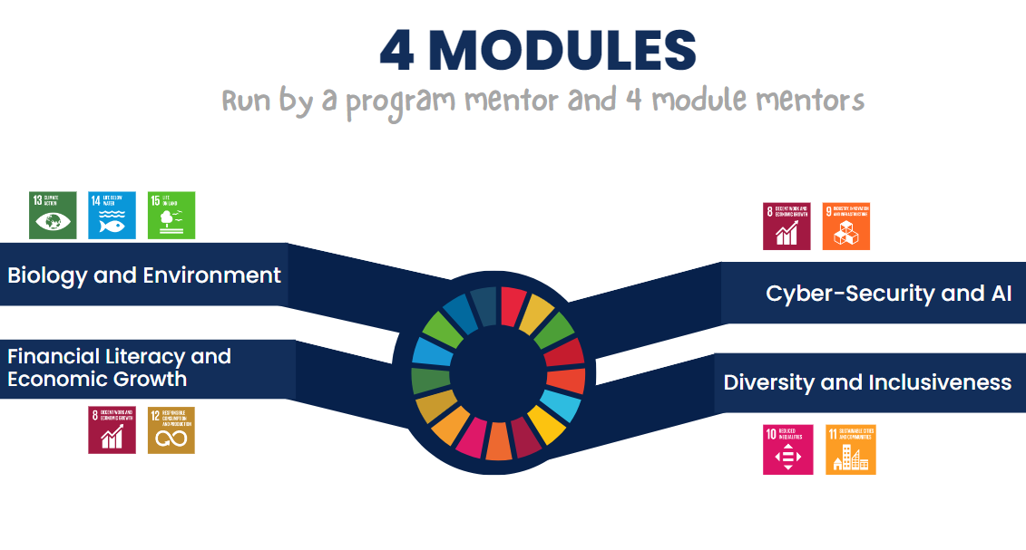

Personal Goals: Employability Skills
- Collaboration and teamwork
- Leadership
- Self-management
- Critical thinking
- Social responsibility

3. Co-hosts:
National University of Singapore, Singapore
University of Southern Queensland, Australia

4. Number of participants:
Undergraduate students 105-120
25 students from Mahidol University
40 students (20 from each co-host)
40 -55 students from partner universities (1-2 students / university)

5. Program fee USD 560 / person (USD 280 / person for MU partners)
Program fee includes
- Accommodation (a shared room for two - three for 6 nights)
- Meals (breakfast and lunch)
- Domestic transportations for site visits and airport transfer
- Two-Day-and-one-night field trip in Kanchanaburi province
All participants are required to cover their air tickets, international insurance, and their own personal expenses

6. Aims and Objectives
To reach the given aim toward the end of the program, a series of activities and learning opportunities will be followed in these 4 modules. A participant can pick one of these 4 modules.
1. Biology and Environment: Understanding and addressing the complex interplay between human activities and the environment is crucial for achieving sustainable development.
2. Cyber-security and AI: As the digital landscape rapidly evolves, the importance of securing digital spaces and harnessing the potential of artificial intelligence for the betterment of society cannot be ignored.
3. Financial Literacy and Economic Growth: Gaining financial knowledge and an understanding of economic systems can empower people to contribute to economic growth and stability.
4. Diversity and Inclusiveness: Embracing diversity and promoting inclusiveness are cornerstones of a harmonious and equitable world, making this module essential for fostering global understanding.

7. Team
7.1 Program Directors:
- Assoc. Prof. Dr. Nopraenue Sajjarax Dhirathiti, Vice President for International Relations and Corporate Communication
- Dr. Chantarath Hongboontri, Faculty of Liberal Arts, Mahidol University
7.2 Four Module Mentors:
Biology and Environment: Dr. Toh Tai Chong, Director of Residential Life College of Alice & Peter Tan, National University of Singapore
Cyber-security and AI: Dr. Michael Lane, Senior Lecturer (Information Systems), School of Business, University of Southern Queensland
Financial Literacy and Economic Growth: Asst. Prof. Dr. Kaewta Muangasame, Tourism and Hospitality Management (THM), Mahidol University International College (MUIC)
Diversity and Inclusiveness: Asst. Prof. Dr.Sumittra Suraratdecha,
Acting Deputy Director for International Relations and lecturer, Research Institute for Languages and Cultures of Asia (RILCA), Mahidol University

8. Program at a glance
 | 6 Jan 2023 | 7 Jan 2023 | 8 Jan 2023 | 9 Jan 2023 | 10 Jan 2023 | 11 Jan 2023 | 12 Jan 2023 | 13 Jan 2023
Morning | Arrival Day | Introduction to program, host and co-hosts  Lecture /workshop  Ice-breaking | Module-based  Workshops | Module-based  Workshops / Site visit | Mixed module workshops  Reflection session | Dept for Kanchanaburi at 6.30 am  Kanchanaburi campus | Kanchanaburi Trip | Departure Day
Afternoon |  | Campus tour  Cultural activity | Module-based  Workshops | Module-based  Workshops / Site visit | Youth voices matter panel discussion | Kanchanaburi Trip | Dept for Bangkok at 1 pm  Check-in at a hotel in Bangkok at 4.30pm
 |  | Mahidol University Salaya | Mahidol University Salaya | Mahidol University Salaya / Bangkok | Mahidol University Salaya | Kanchanaburi | Kanchanaburi /  Bangkok
Remark: Day 0 is arrival day, day 7 is departure day

9. Timeline
Item to be Completed | Proposed Date of Completion
Participant Recruitment | 12 October 2023 – 20 November 2023
List of participants confirmation | 2 December 2023
Arrival day | 6 January 2024 (Sat)
Program | 7-12 January 2024
Departure day | 13 January 2024 (Sat)

10. Nomination Process
1. Universities or partner universities start internal recruitment process.
2. Universities or partner universities nominate 1-4 students to Mahidol University by 20th November 2023. Please be informed that the acceptance will be processed on a first-come, first-served basis. We do not accept direct application from students.
3. Students and coordinators will receive the confirmation email with payment details and necessary information within 7 working days.
Application form and program can be downloaded at https://op.mahidol.ac.th/ir/dcu-camp/

11. Program coordinator
Please feel free to contact us via the addresses listed below if you have any queries.

Mr. Charlton Alexander Lim
Foreign Expert <charlton.lim@mahidol.ac.th>

Miss Britney Chonlada Prommachartsuntorn
International Relations Officer <chonlada.pro@mahidol.edu, sawasdee.mahidol@gmail.com>

International Relations Division, the Office of the President
Mahidol University

